This guide will help walk through updating mcompass®. This will work for both mcompass® Anorectal Manometry (ARM) and Manometric Biofeedback (MBF). This guide can also be applied to future updates as well, as the uninstallation and installation steps will be the same and is the same for both ARM and MBF. Some locations may require the assistance of their local Clinical IT Department to update.

The latest version of mcompass® Anorectal Manometry (ARM) and Manometric Biofeedback (MBF) can be downloaded from the following website:

* <https://medspira.com/software-download>
* Password: **M3d5p1r@SW**

If you are unable to download the installation files or need assist with installing the update, please reach out to Medspira Support at [Support@medspira.com](mailto:Support@medspira.com) or 612-789-0013, Option 1.

**\*ARM - If you have an older mcompass® ARM version that is not 1.07.x, please contact Medspira Support to assist with the update.** *(Version number is display under the mcompass® logo when mcompass® loads)*

## **Please follow the steps below to update mcompass®**

Please allow yourself 15-30 minutes to do the update.

When updating, we recommend uninstalling the current ARM and/or MBF versions first to prevent any confusion or unintended use of the older versions, prior to installing the updated ARM and/or MBF:

### Uninstalling mcompass® ARM & MBF:

* 1. Windows 7 Devices  (Start menu logo is a circle)
     1. Click/tap **Start**,
     2. Click/tap **Control Panel**,
     3. Click/tap **Programs and Features**,
     4. Look for and click/tap **mcompass XXXX/mcompass® Diagnostic** or **mcompass biofeedback XXXX/mcompass® Biofeedback** to highlight,
     5. Click/tap **Uninstall**,
     6. If a security window pops up to uninstall, click/tap **OK** to uninstall.
  2. Windows 10 Devices  (Start menu logo is a square)
     1. Click **Start**,
     2. Click **Settings **,
     3. Click **Apps**,
     4. Look for and click/tap **mcompass XXXX/mcompass® Diagnostic** or **mcompass biofeedback XXXX/mcompass® Biofeedback** to highlight,
     5. Click **Uninstall**,
     6. If a security window pops up to uninstall, click **OK** to uninstall.

### Installing **mcompass® ARM**:

1. Navigate to the location where the mcompass® ARM update software has been downloaded to, normally it would be in the **Downloads** folder as the default location, unless the location has been changed.
2. Look for the **mcompass® ARM** folder and click/tap it to open, *(verify the version number is the latest)*
3. In the folder,
4. If using a mouse, right click **setup.exe** to get the function pop up window, then click **Open** to start the installation.
5. If using the table touch screen, tap and press the **setup.exe** for a few seconds to get the function pop up window, then tap **Open** to start the installation.
6. The updated mcompass® desktop icon will now say **mcompass® Diagnostic**. Graphical user interface, application

   Description automatically generated

### Installing **mcompass® ARM *Lite***:

1. Uninstalling and installing mcompass® ARM *Lite* is the same as the mcompass® ARM software.

### Installing **mcompass® MBF:**

* 1. Navigate to the location where the mcompass® ARM update software has been downloaded to, normally it would be in the **Downloads** folder as the default location, unless the location has been changed.

1. Look for the **mcompass® MBF** folder and click/tap it to open, *(verify the version number is the latest)*
2. In the folder,
3. If using a mouse, right click **setup.exe** to get the function pop up window, then click **Open** to start the installation.
4. If using the table touch screen, tap and press the **setup.exe** for a few seconds to get the function pop up window, then tap **Open** to start the installation.
5. The updated mcompass® desktop icon will now say **mcompass® Biofeedback**. Graphical user interface

   Description automatically generated with low confidence

### Installing **mcompass® MBF *Lite***:

1. Uninstalling and installing mcompass® MBF *Lite* is the same as installing the mcompass® MBF software.
2. **Starting/Opening ARM and MBF for the first time after update/installation**:
3. Upon opening mcompass® ARM and MBF for the first time after update/installation, mcompass® will need to be **Run as Administrator** to register the program with the database, to do this, open the on-screen keyboard, press the **Shift** key, tap and hold the mcompass® icon on the desktop to open the function drop-down window, then select **Run as Administrator** to start/open mcompass®. When mcompass® opens, click **Diagnostic Anorectal Manometry** for **ARM** and **Pelvic Floor Retraining** for **MBF** then log in with **Admin** or any user to register ARM/MBF with their respected database. This will only need to be done once when opening ARM for the first time after update/installation. Further instructions can be found towards the end of the Update Guide under How to Run as Administrator.

### Set or Verify the COM# in mcompass®:

1. First you will need to find the Bluetooth Communication Port number (COM#), to do that click/tap on the Bluetooth icon  down by the time/date.
2. Click/tap **Open Settings** to open the Bluetooth Settings.
3. For Windows 7:
   * + 1. In the **Bluetooth Settings** window,
       2. Click/tap the **COM Ports** tab,
       3. **NOTE** down the **Outgoing COM#** for **Medspira AMP-SPP ‘AMP-SPP’** or **AMPED-UP**,as you will need that for the Bluetooth setting in mcompass®.
4. For Windows 10:
5. In the **Bluetooth & other devices** screen,
6. Scroll down towards the bottom,
7. Look for and click/tap **More Bluetooth options**, to open the **Bluetooth Settings** window,
8. Click/tap the **COM Ports** tab,
9. **NOTE** down the **Outgoing COM#** for **Medspira AMP-SPP ‘AMP-SPP’** or **AMPED-UP**, as you will need that for the Bluetooth setting in mcompass®.
10. Once the Outgoing COM**#** has been noted, start/open mcompass® Diagnostic and/or mcompass® Biofeedback,
11. Click/tap **Administrator** in the top right,
12. Login using the **Admin** credentials,
13. Click/tap the **Bluetooth** tab on the left,
14. Click/tap the **Up** or **Down** arrow to change the COM Port # to the same Outgoing COM Port # noted in the **Bluetooth Settings** screen.
15. Click/tap **Connection Test** to verify and confirm that mcompass® is able to communicate with the FOB. You should see a **Connection Test Result** like the one below:

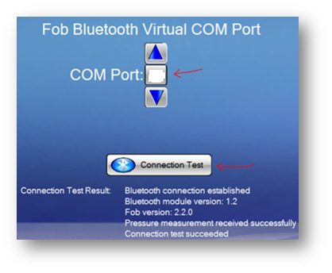

1. Once connection has been verified, press **log out**,
2. Now you can Exit to Windows or log into **Diagnostic Anorectal Manometry** (ARM) or **Pelvic Floor Retraining** (MBF) to start the test.

For any questions, concerns or issues please don’t hesitate to reach out to Medspira Support for assistance.

Thank You,

Medspira Support

**Medspira LLC**

2718 Summer Street NE

Minneapolis, MN 55413

Phone: (612) 789-0013, #1

Toll-Free: (800) 345-4502, #1

[Support@medspira.com](mailto:Support@medspira.com)

**Common Error(s)**

The following error screen will pop-up when attempting to open and log into mcompass® after a new install or update. Please run mcompass® as Administrator and log into mcompass® with the **Admin** login once to register the program with the database.

**How to Run as Administrator**

1. A picture containing graphical user interface

   Description automatically generatedLocate the touchscreen keyboard to the bottom right next to the clock area and tap the keyboard icon to bring up the touchscreen keyboard.
2. A picture containing text, electronics, keyboard, computer

   Description automatically generatedTap the **Shift** key so that it is highlighted.
3. With the Shift key highlighted locate the mcompass® icon on the desktop and **Long Press** on it to bring up the menu.

*Notes: Small movements during the Press will fail to register as a Long Press and bring up the Copy here, Move Here, Create shortcuts here menu instead.*

1. A picture containing text, electronics, screenshot

   Description automatically generatedFrom the menu select **Run as administrator**
2. If using a **Mouse** and **Keyboard**, press and hold **Shift** on the keyboard, then right mouse click the mcompass® icon to bring up the menu to select **Run as Administrator**.
3. When asked “**Do you want to allow this app from an unknown publisher to make changes to your device?**”

Select **Yes**

1. From the mcompass® program select: **Diagnostic Anorectal Manometry** or **View Reports** for ARM

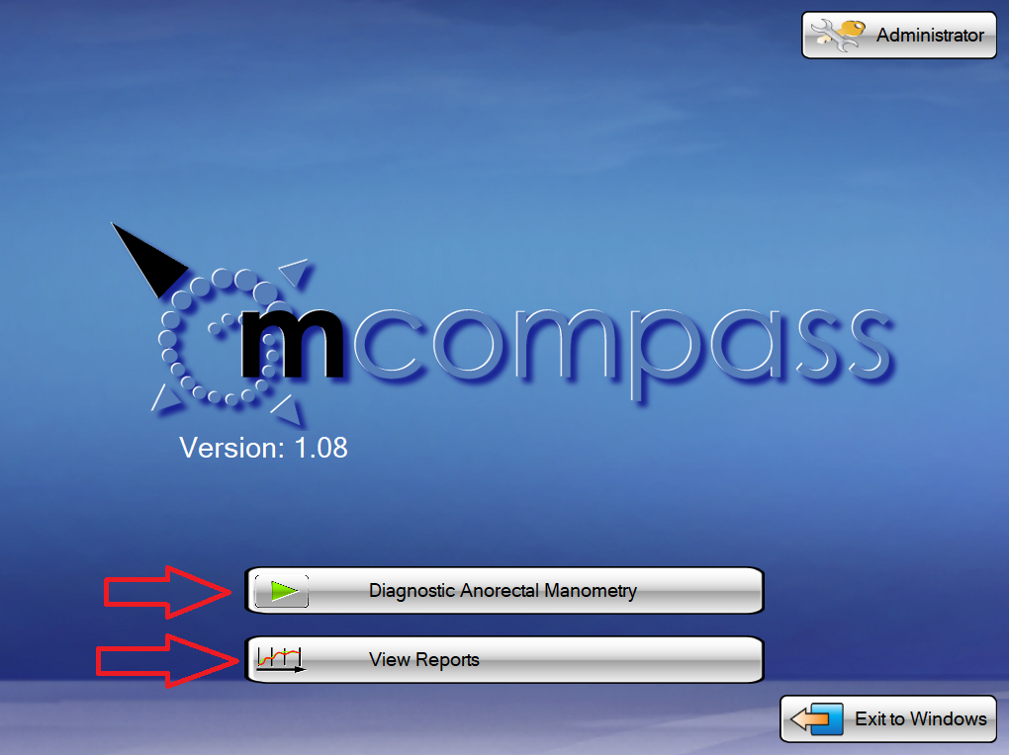

And **Pelvic Floor Retraining** or **View Reports** for MBF

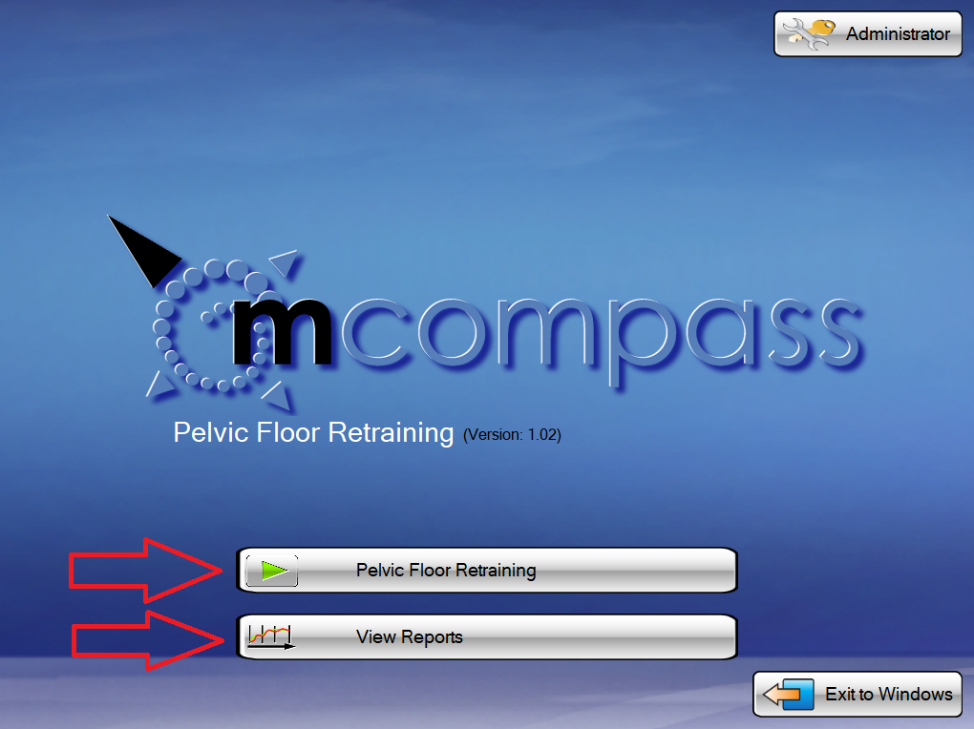

1. **Login** as you normally would to start a test,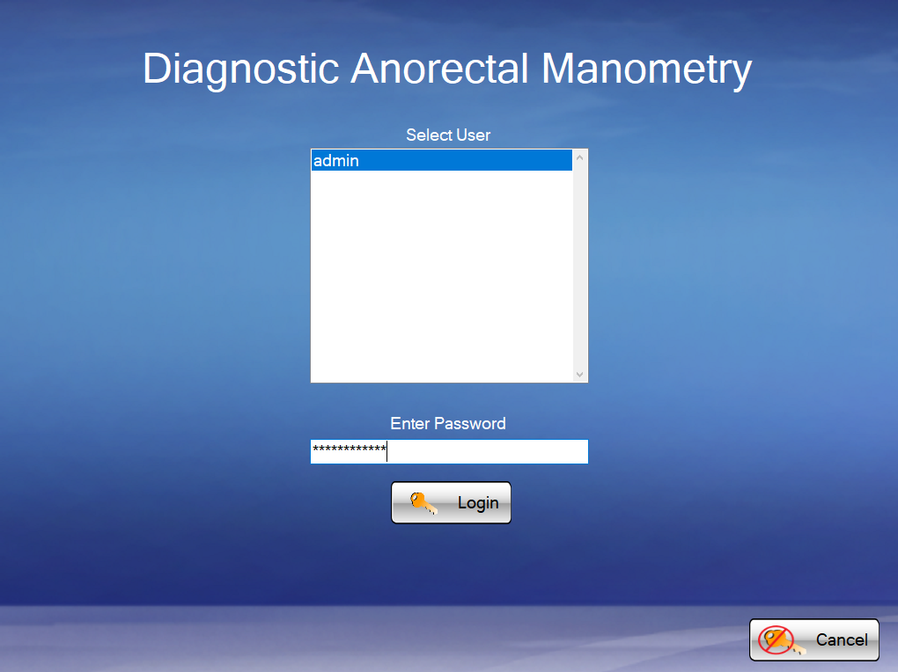
2. After this the new/updated mcompass® program will be registered with the existing mcompass® database. **Run as Administrator** will only have to be done once after an update or new install.

mcompass® can now be open normally again by double tap/click the icon on the desktop.