HOW TO PAIR YOUR FOB TO YOUR MCOMPASS TABLET
- Click start Control Panel Hardware and Sound Add a Device
- Look for Medspira AMP-SPP and click next
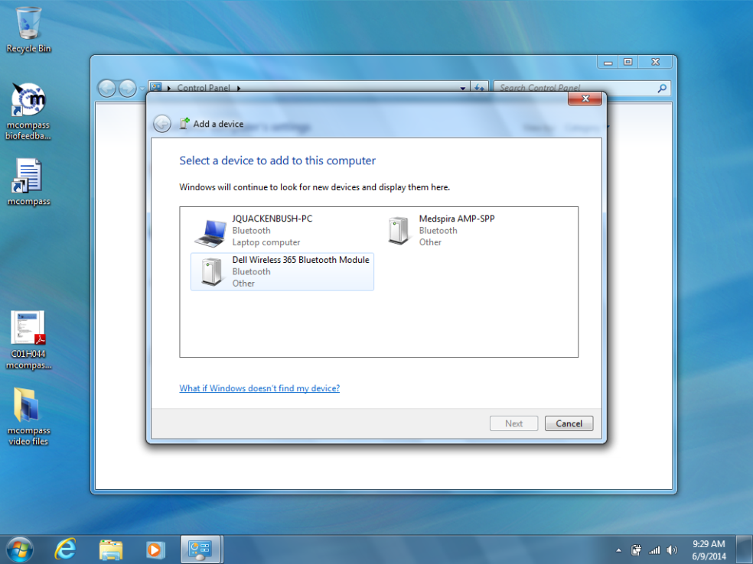
- Click “Enter a Device’s Pairing Code”
- Enter pairing code “1234” click next
- Should say “device successfully added”
CHECKING THE PORT OF THE FOB (Steps should be taken from here for troubleshooting as well)
- Start Control Panel Hardware and Sound View Devices and Printers
- Click on Medspira AMP-SPP (as should have been added)
- Click on Properties
- Click on hardware tab
- Under Device Functions it should read “Standard Serial Over Bluetooth Link (COMX)
- X represents the portal that the FOB is on (should be a number 1-10)
- Open the mcompass software
- Click on administrator and log in (top right corner)
- Click on the Blue Tooth tab
- Switch COM to corresponding with X from above (same number 1-10)
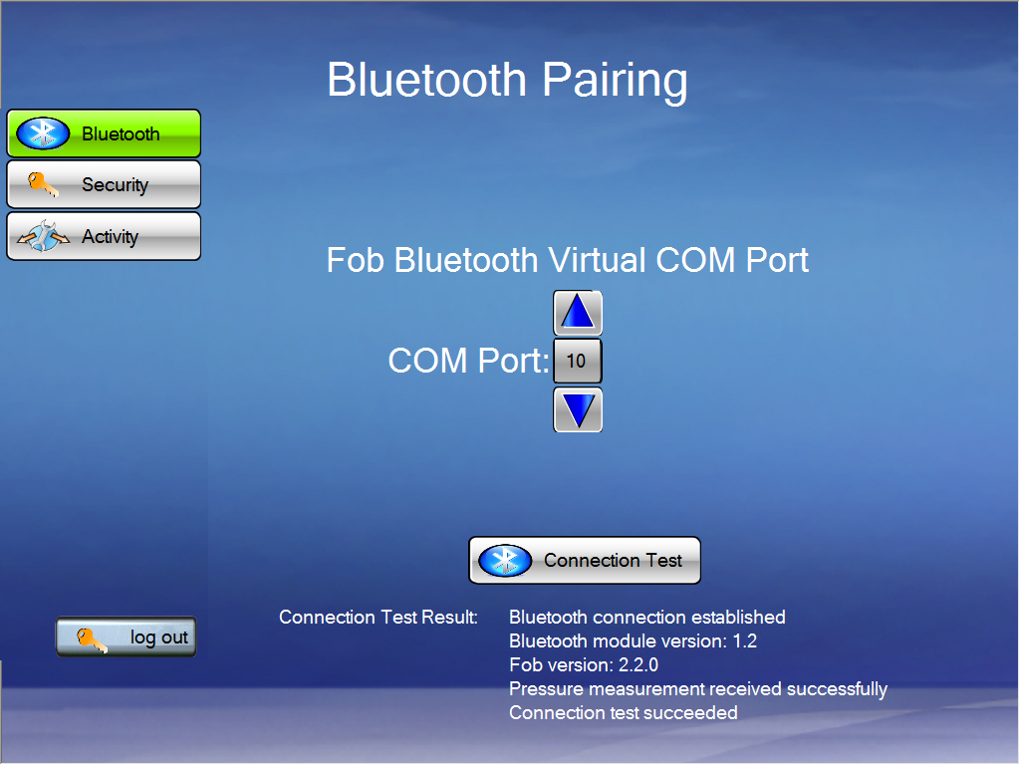
- Click Connection Test
- Results should read “Bluetooth connection established”

