How to Pair Your FOB to Your MCOMPASS Tablet!
- Click the Start button then click the little gear symbol (Settings)
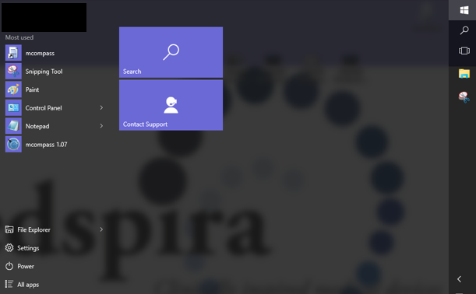
- Click into Devices then go to Bluetooth and be sure to turn the fob on for discovery.
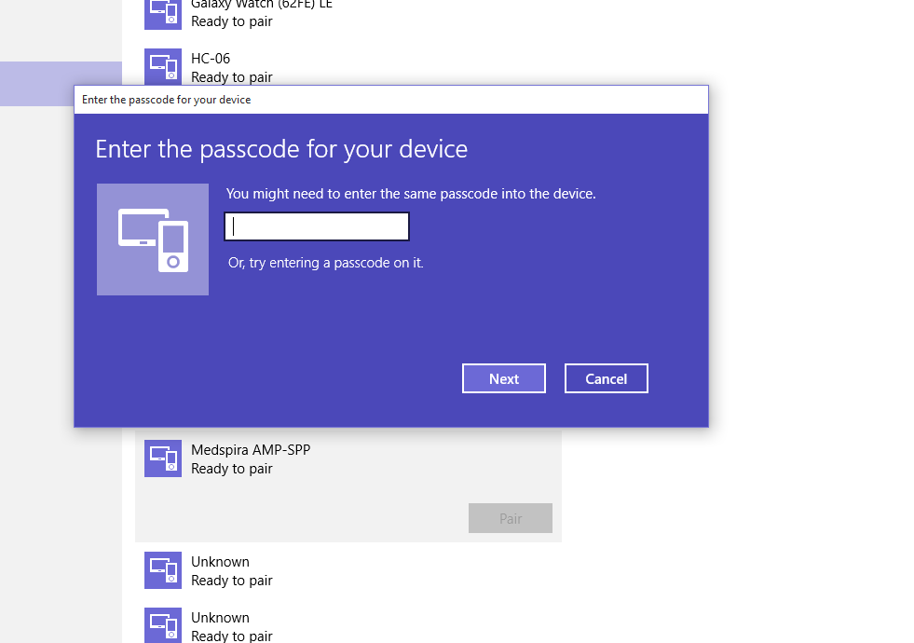
- Look for Medspira AMP-SPP or Amped Up and click on the Fob name and enter “1234”
- Before navigating out of the Bluetooth options click the “More Bluetooth Options” at the bottom of the page.
- It will pop up a window for Bluetooth options and then click into COM Ports (Note the outgoing COM port #).
- You can close the setting window and then navigate to the mcompass software.
- Click on Administrator, then Bluetooth and use the arrows to get to the com # from Bluetooth settings.
- Lastly, click connection test and you should see “Bluetooth connection established”

